

EE 463

STATIC POWER CONVERSION I

HARDWARE PROJECT FINAL REPORT

Orhun TAŞOĞLU 2094506

Mert ZEYBEK 2167682

Kutay DELİBAŞ 2093599

Submission Date: 15.01.2019

# Introduction

In power electronics, controllable AC-DC converters are used commonly in our daily life. They allow us to transfer power from one side to another and get the desired output values. Desired factors of these converters are high efficiency, high power density, low cost and reliable output. There should be a balance between those factors, and a design itself may not be enough to determine those things.

In this project, such an AC-DC converter is designed and implemented, and tested on a large industrial DC motor to drive a generator. For the design, certain choices such as topology selection and control method were made in order to keep it simple and effective, which will be explained in this report. Following the design, simulation of the design is done with Simulink. Afterwards, implementation and testing of the project began. As this process advanced, design was also slightly altered and improved in order to keep the implementation realistic and successful. Thermal design was also considered, which affected choice of components as well as layout of the implementation. Finally, the converter was tested with R load and also with the DC motor to transfer power. These test results will also be provided in this report.

# Design Choices

After the simulation report is submitted and our suggested system topology is verified, some parts of the system needed to be designed in detail. PWM Generator, Optical Isolator & Gate Driver needed to be implemented to replace the PWM block in the simulation. Since we worked with real circuit elements, there were more elements which were not in the simulations but should be taken into consideration. Heat dissipation of semiconductors, stray inductances, placement of the components and ensuring proper connections were critical for proper and robust operation. Block by block, details about design choices are given in this section.

## Topology Selection

3-Phase Rectifier and Buck Converter topology with low side switching is used as it was proposed in the Simulation Reports. As expected, the motor provided enough filtering and it was proven that LC filter was not needed in our case. Making this decision saved us both time and money, since finding a suitable inductor in the market that is ready to purchase would be more or less impossible and it needed to hand wound. In other words, buying more components and spending extra time.

Implementing low-side switching eliminated the need for isolated supply, however an optocoupler is used in case. Moreover, it helped us eliminate the need for a second power supply. As a result, our design became less complex, using only one DC supply.

## PWM Generation

To generate PWM signal with adjustable duty cycle, TL494 IC is used. It is chosen since the chip is widely available (also in the laboratory), it is analog so does not require software programming and implementation is easy & understandable. A potentiometer is used to change the duty cycle which is actually a basic voltage divider. Difference between the potentiometer output and reference signal is used to calculate desired duty cycle by the IC. The circuitry is given is Figure X.

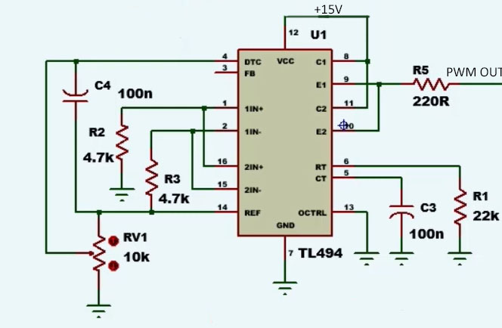

However, using this circuit to directly drive the IGBT would be impossible since TL494 can not supply the desired current to turn on the transistor. Therefore, additional circuitry was needed.

## Optocoupler & Gate Driver

A gate driver was needed to be able to use the generated PWM as the gate signal as mentioned. Also, to isolate the sensitive low voltage components from the high voltage paths where also high currents pass, using a optocoupler is a good security measure to prevent the components getting harmed in case of a failure.

An analog amplifier could have been used for gate signal part, but since TLP250 IC can handle both of our requirements, the IC is used, in the circuit given in Figure X.

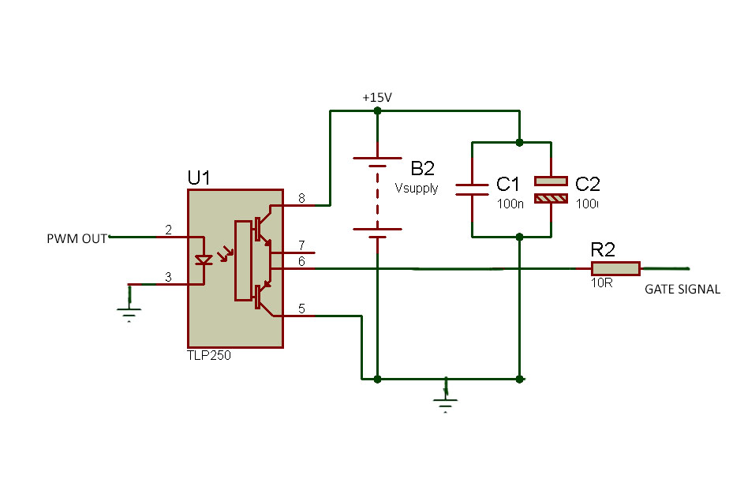

## Semiconductor Components Selection

While choosing semiconductor elements, our main aim was finding the optimum spot considering the trade-off between cost and efficient and robust operation. In order to select proper semiconductors, voltage and current stresses we acquired in Simulation Report are used. Selecting components with much higher ratings than stress values would assure proper operation of the system, but it would increase cost, which is not desired obviously. Selecting components whose ratings are too close to stress would risk the circuit’s operation. Inrush currents at the starting of the operation, parasitic effects such as ESR values, cable inductances may change stress values, that would cause failure of semiconductor devices. As a result, cost could have still increased since it would be necessary to replace them.

First semiconductor component that was considered is bridge rectifying diode. Although our initial design was using 6 single diodes for this stage considering heating, we changed it to bridge diode. Considering bridge diode’s thermal ratings we decided that it would not cause any problem in terms of thermal design. It is also easier to solder bridge diode, which is another advantage.

For bridge diode, 36MT160, whose ratings are 1600 V off-voltage and 35 A load current is used.Its photo is given below. In simulations, we observed -160 V on bridge rectifier which was way below than our component’s voltage rating. Current was the limiting stress on this case. We observed 40 A average on simulations. This value was higher than the actual value due to spikes in simulation, which were not present in real applications due to cable’s inductance.

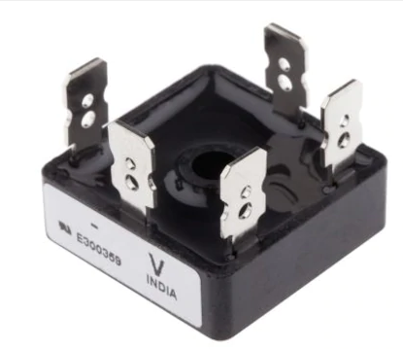

Another diode that we used was freewheeling diode. In simulation results, stress on freewheeling diode was measured as 25 A and 160 V. DHG30I600PA is used, whose ratings are 30 A and 600 V. One main advantage of this diode is its fast-recovery feature. It managed to fully turn-on and turn-off with 1.3 kHz frequency. Since our operating frequency was not too high, we did not need to use ultra-fast recovery diode.

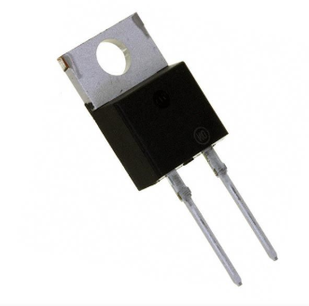

Final semiconductor that we used was transistor. Between MOSFET and IGBT, we decided to use an IGBT transistor since our operating frequency is not too high but we wanted to supply 2 kW power while supplying power to kettle. IGBTs also have lower on-resistances which is desired since we wanted to achieve higher efficieny. As a results, IGBT was more suitable for our operation. According to simulation results, VDS  value was 160 V and IDS was 25 A. IXGH24N60C4D1 IGBT was selected, whose ratings are 600 V and 30 A.

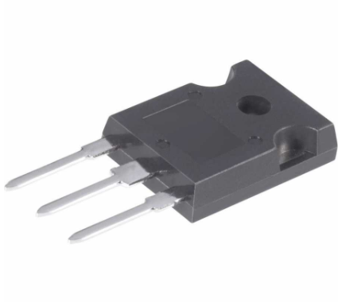

## Other Components Selection

In capacitor selection, we wanted to minimize ripple voltage, so that input of buck converter would be close to ideal DC. In order to achieve that, we wanted to select a capacitor with high capacitance to keep voltage changes at minimum. On the other hand, increasing capacitance too much would increase price significantly. We paid attention to voltage rating of capacitor. Simulation results gave us 160 V on the capacitor. We chose a capacitor with 400 V rating, which can handle higher voltages that might occur at some instants. We also paid attention to select a capacitor with smaller ESR, in order to keep efficiency high and decrease ripple among capacitors with desired ratings.

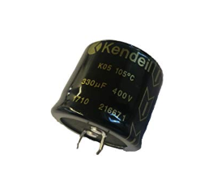

## Thermal Design & Heatsink Selection

Thermal design of the project was done using Lumped Parameter Model. Since most heat dissipation is done on the switching MOSFET, the heatsink choice for that was done using this model. Required heatsink thermal resistivity was found using the following formula

Rheatsink= (Tj -Tamb)/P - Rth-jc (1)

Where

Tj : junction temperature

Tamb: ambient temperature

P : heat dissipated from the heat source

Rth-jc : junction to case thermal resistance

These values were read/calculated from datasheets of the components.

For MOSFET:

Tj max= 175 C => choose Tj =150 C

Tamb= 25C

Rth-jc= 0.80 C/W

P= f. Ets = 1360 Hz . 1.46 mJ = 1.98 W

Rheatsink= 62.33 C/W

For MOSFET, aluminum heatsink with dimensions 11.50x30.00x29.00mm was selected that offers

8.41 °C/W in natural convection setting, which is enough for the design. A similar separate heatsink was selected for freewheeling diode, which is also enough since it dissipates considerably less energy. The heatsinks can be seen in Figure X below.

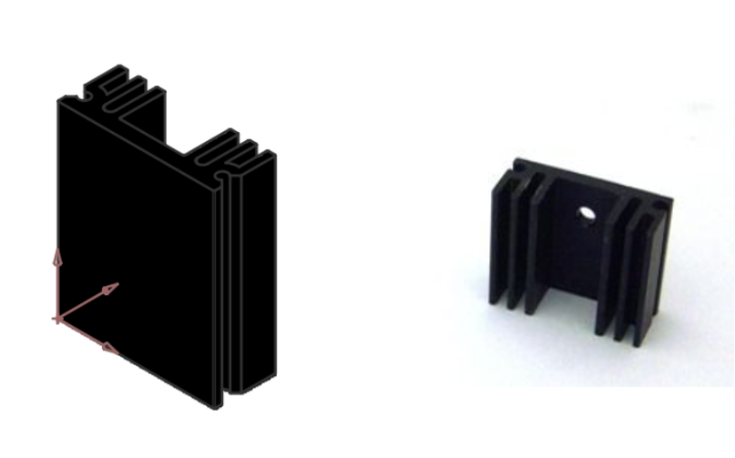

Figure X: 2 heatsinks that are used for MOSFET(left) and FWD (right)

# Simulation Results

# Test Results

## Lab Tests

## Demo-Day Tests

# Cost Analysis

# Challenges

# Conclusion